**Green Society Public School**

**Ratnanagar-7, Sauraha, Chitwan**

**Second Terminal Examination-2082**

**Class: Three Time: - 1 hr. F.M.: 25**

**Sub: Science**

|  |
| --- |
| **Name: Roll No.: Sec.:** |
| **­­­­­­­­­­­­ ________________ ______________ OBT.MARKS:**  **INVIGILATOR EXAMINER** |

**1. Tick (√) the correct answer. (4×1=4)**

a) Which one is a desert animal?

i) Penguin ii) Camel iii) Panda

b) Which animal is a herbivore?

i) Hare ii) Fox iii) Wolf

c) Which animal is used for transportation?

i) Cat ii) Rabbit iii) Horse

d) Which one is a communicable disease?

i) Corona ii) Asthma iii) Cancer

**2. Write True or False. (4×1=4)**

a) Communicable diseases can pass from one person to another. ( )

b) Smoking is good for health. ( )

c) Salads are eaten without cooking. ( )

d) Moth is an insect. ( )

**3. Match the Following. (4×1=4)**

Non-communicable Nicotine

Smoking Nicotine Diabetes

Medicinal Plant Insect

Frog Aloe vera

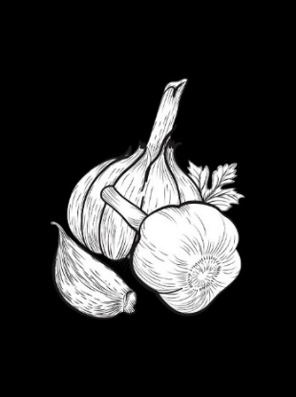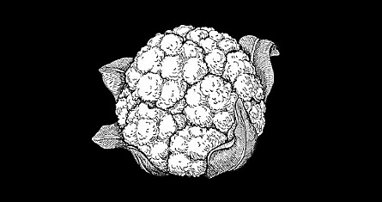**4. Identify the picture. (2×1=2)**

**5. Answer the following. (4×2=8)**

a) How do fish move in water?

_______________________________________________________________________________________________________________________________________________.

b) Name any 2 grain-eating animals.

________________________________________________________________________________________________________________________________________________________________________________________________________________________.

c) What are the sources of food?

________________________________________________________________________.

d) Who are called passive smokers?

________________________________________________________________________.

**6. Draw the following. (2×1=2)**

|  |  |
| --- | --- |
| **Pet animal** | **Domestic animal** |
|  |  |

**The End**